Batch: B3 Roll No.: 16010122158

Experiment No. 02

TITLE: Develop and demonstrate the usage of inline, internal and external style sheet using CSS

AIM: To demonstrate usage of CSS
______________________________________________________________________
Expected Outcome of Experiment: Use CSS to prepare the layout of web pages.
______________________________________________________________________
Books/ Journals/ Websites referr ed:
- https://developer.mozilla.org/en-US/
- https://developer.mozilla.org/en-US/curriculum/core/css-text-styling/
_____________________________________________________________________
Importance of CSS in designing of a website is to be explained. Explain various ways to use CSS. Also explain how to change background colour of page, adding and editing border types, adding navigation bars, usage of various types of 2D and 3D transformation.
Description of the CSS style code with its effect at output:

Code Screenshots

main.html
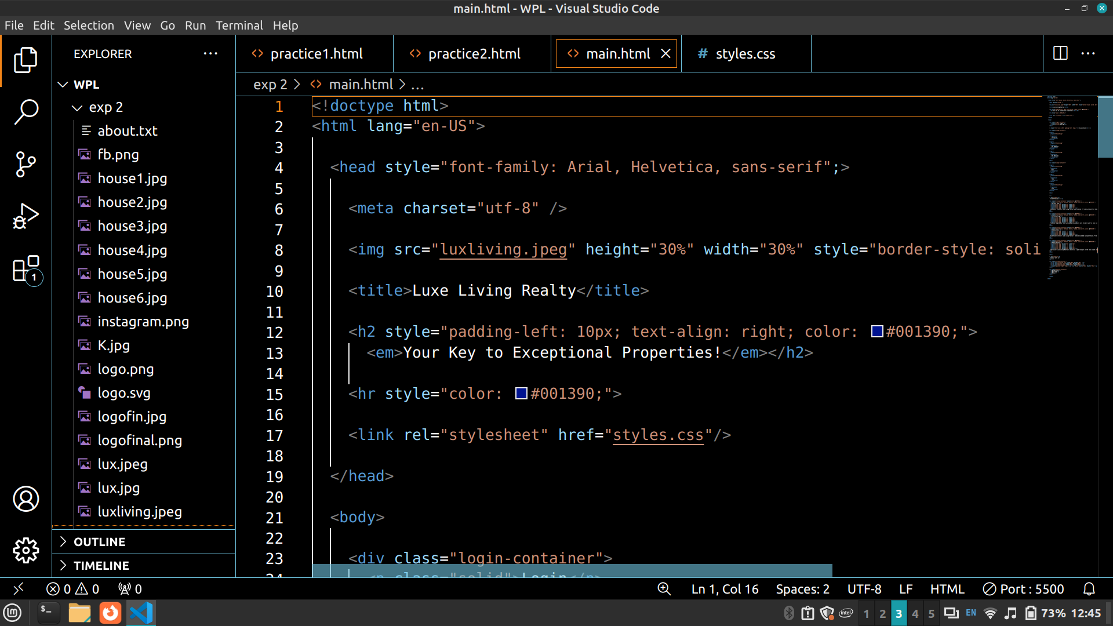
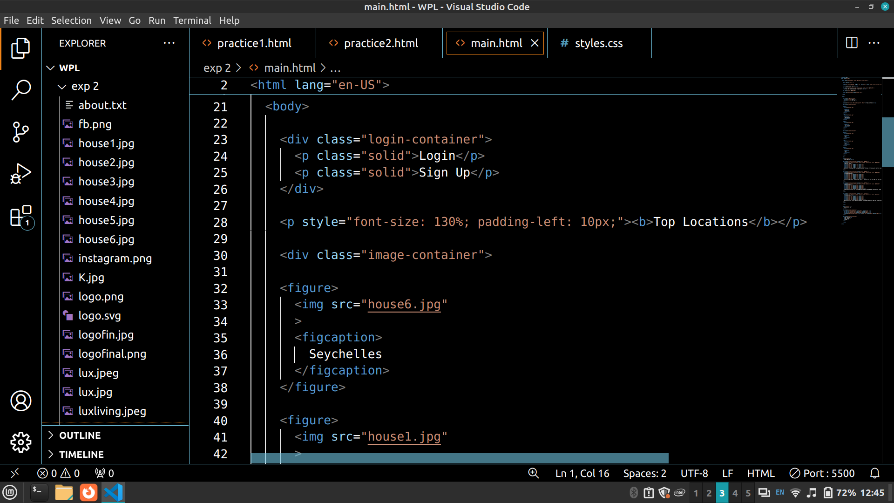
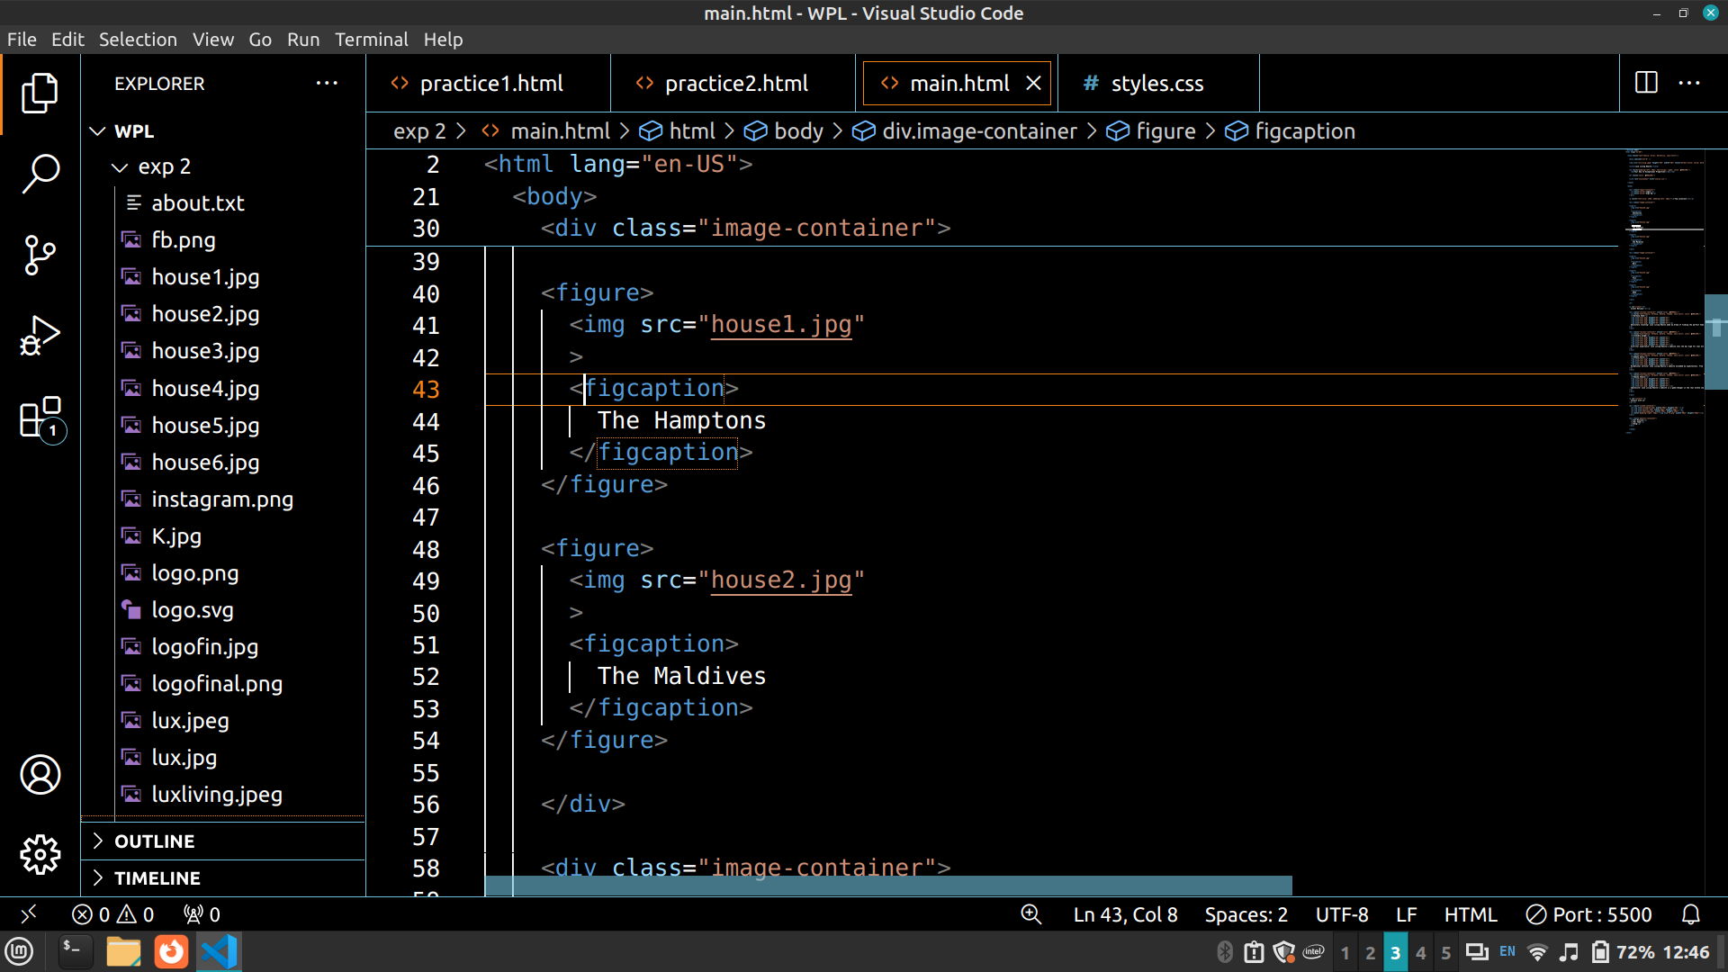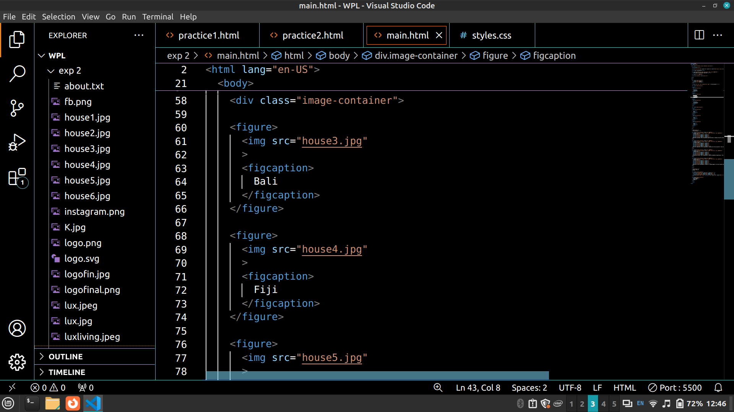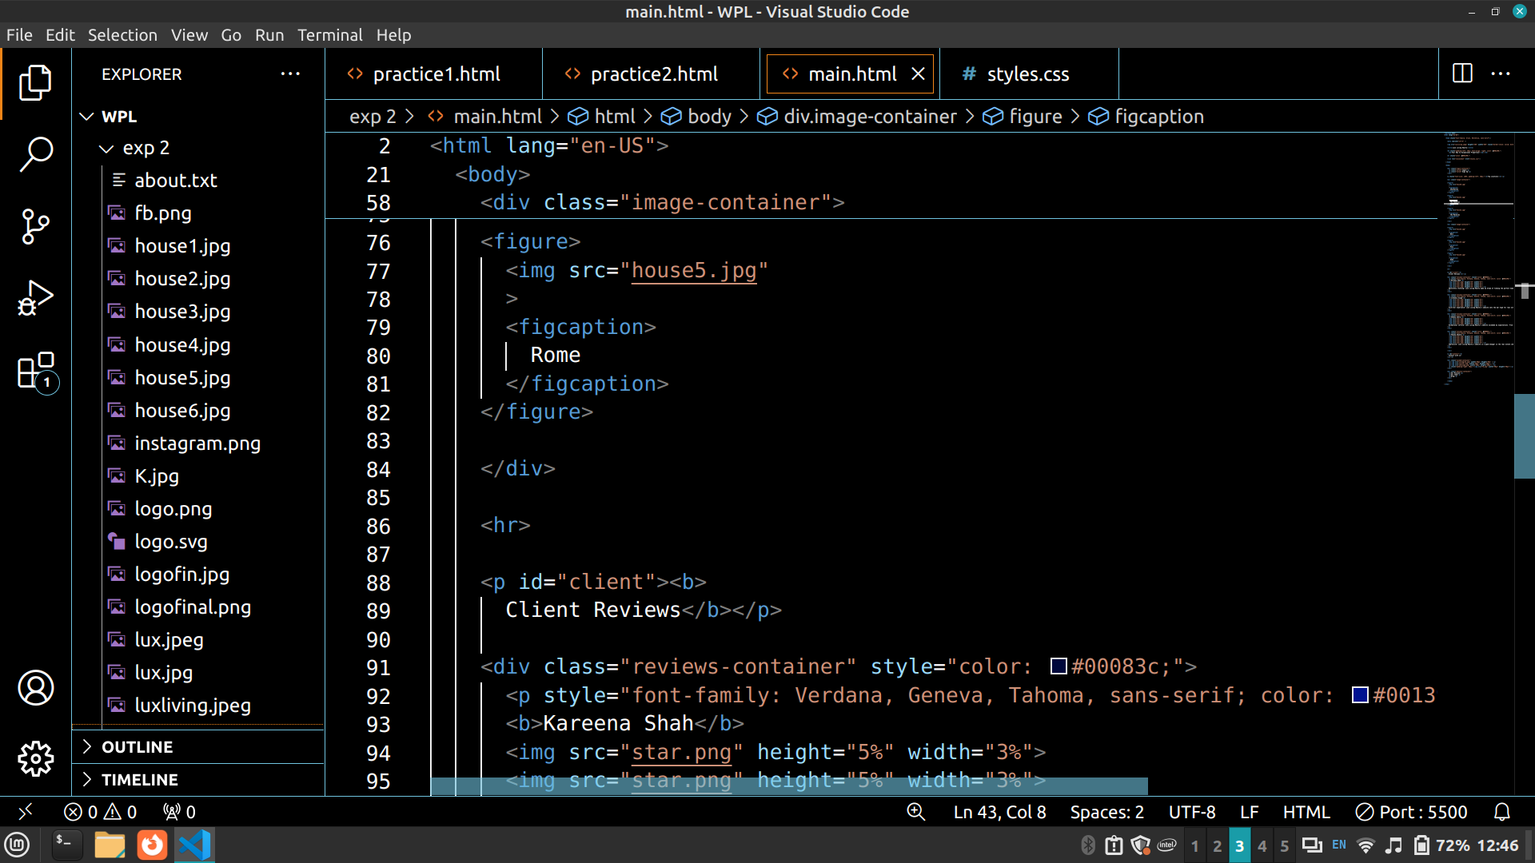
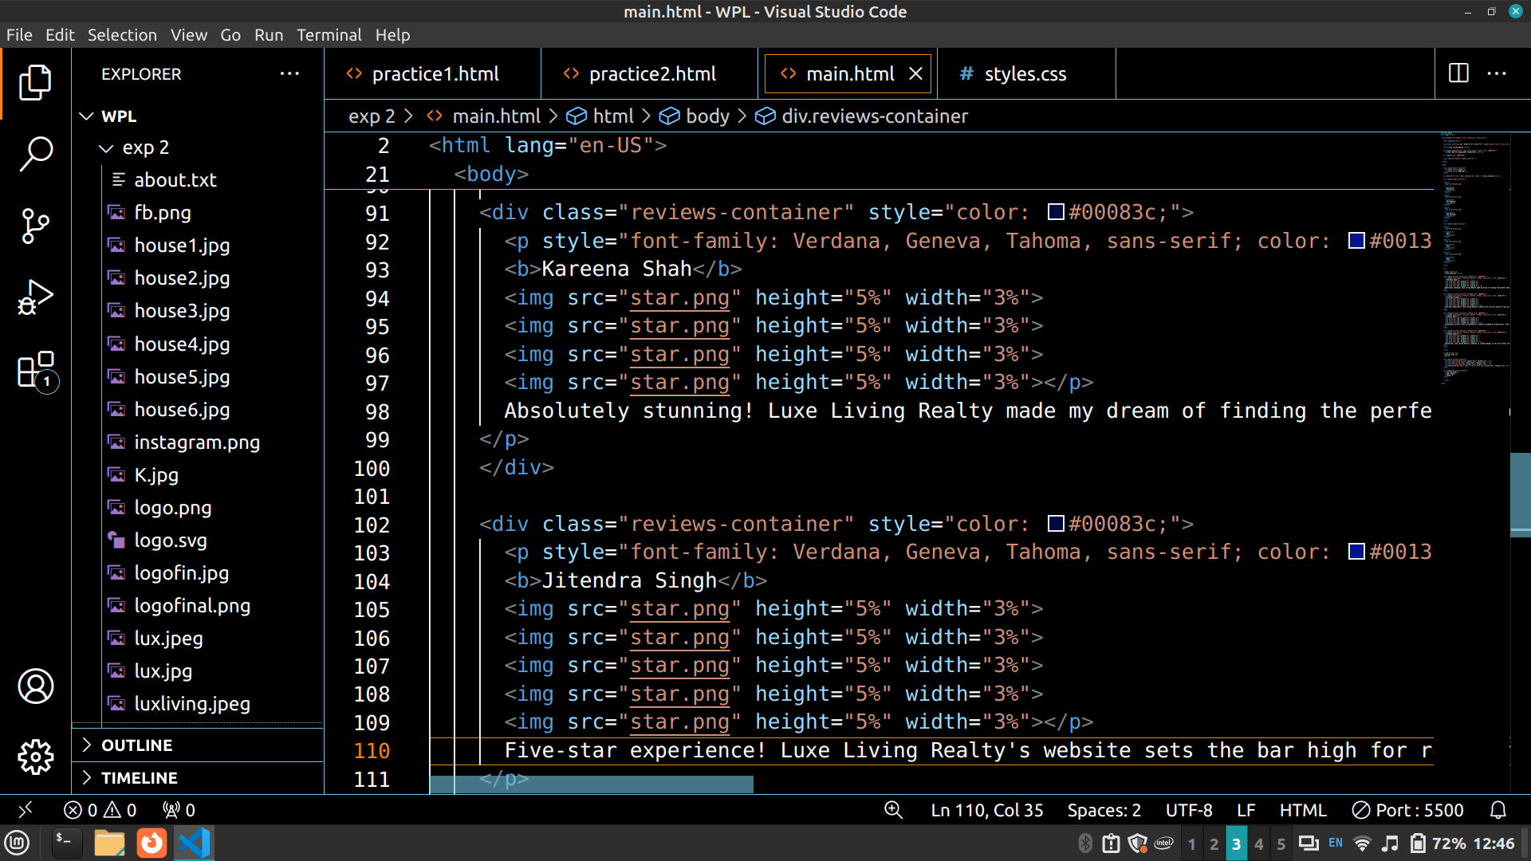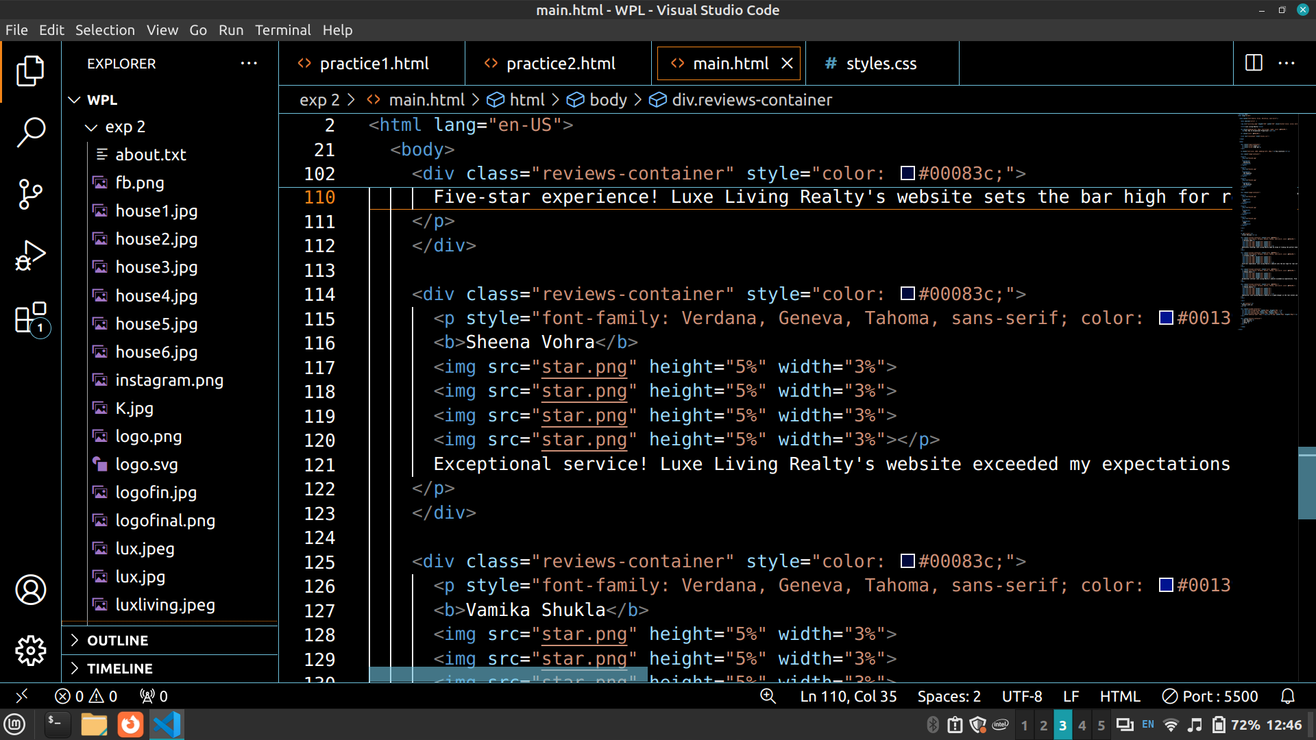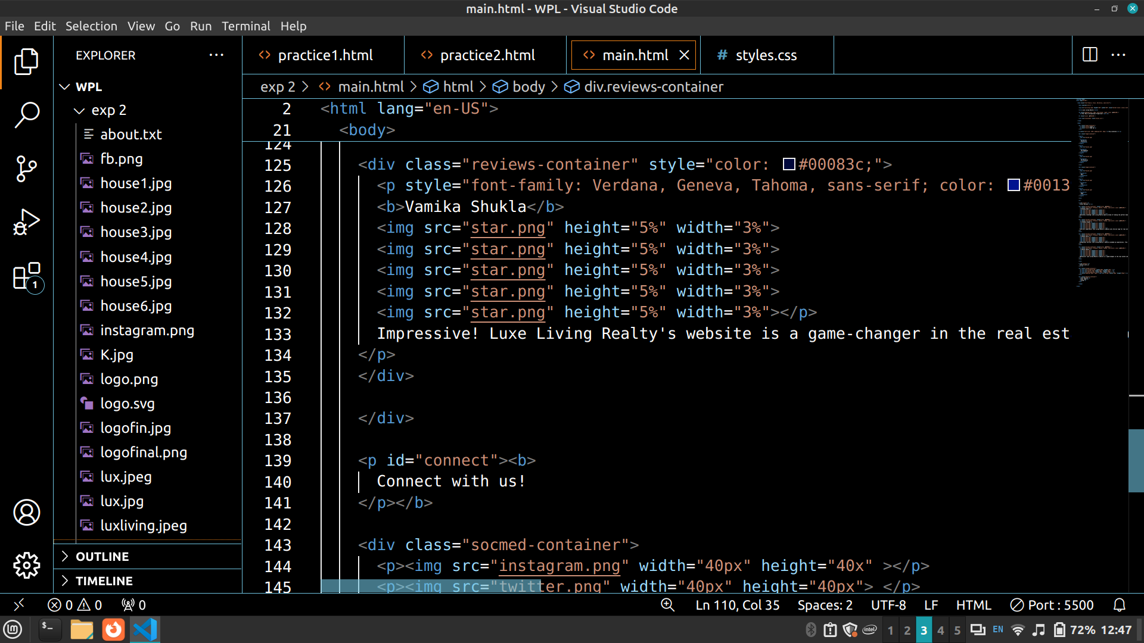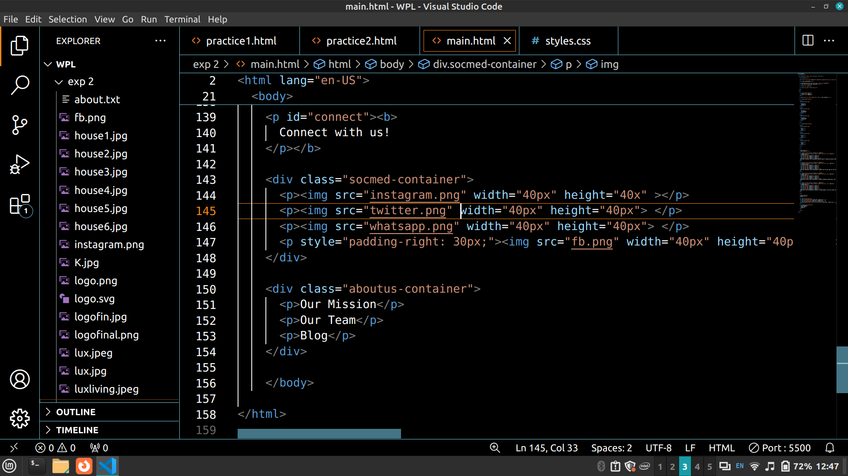

styles.css
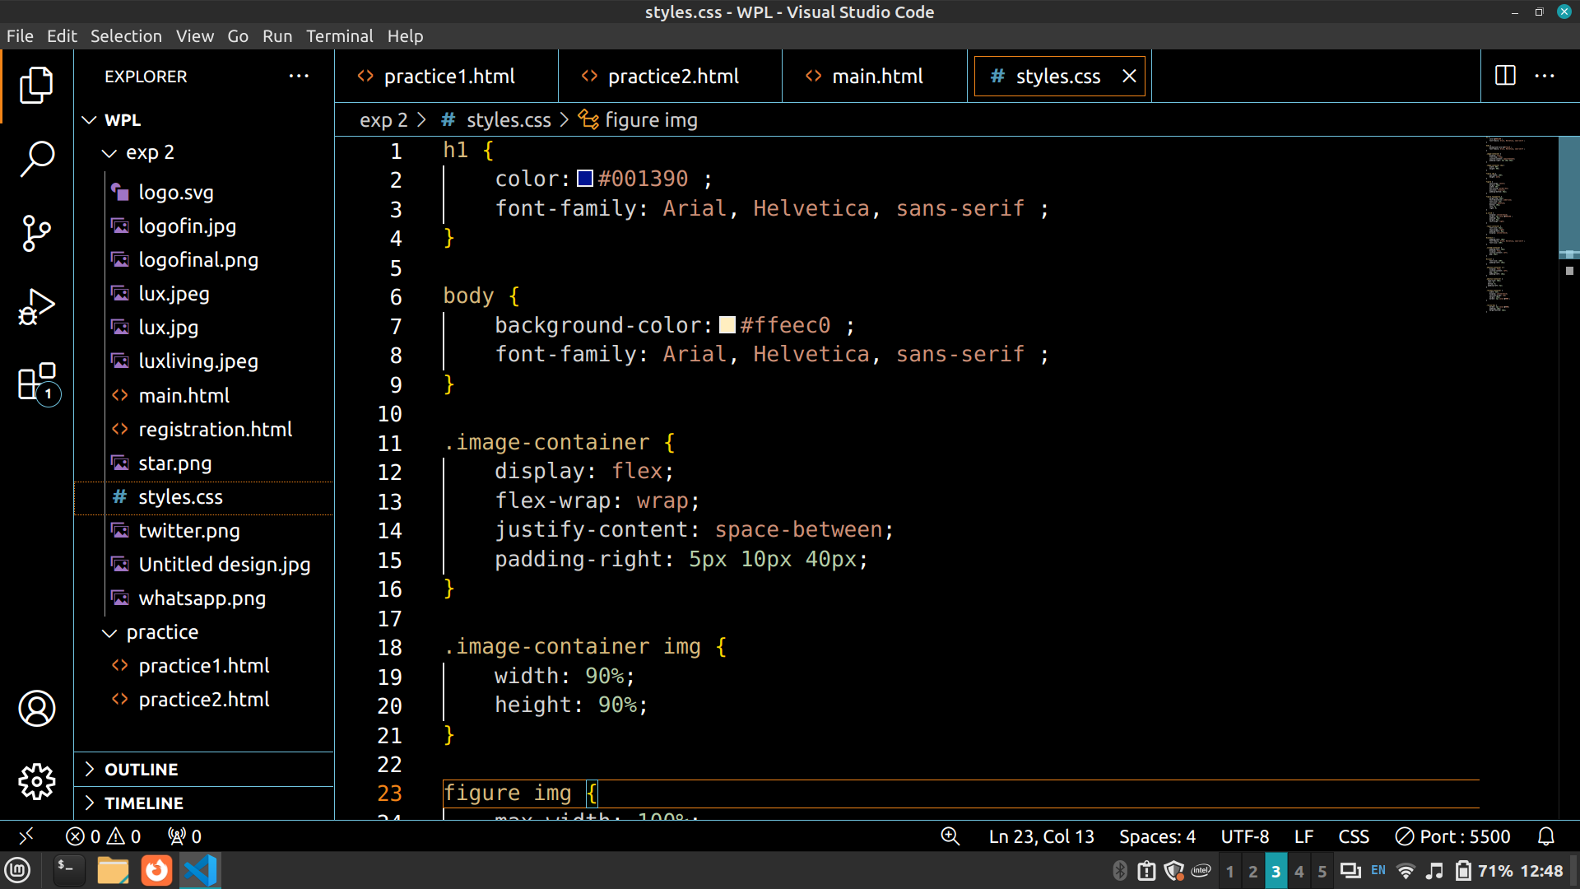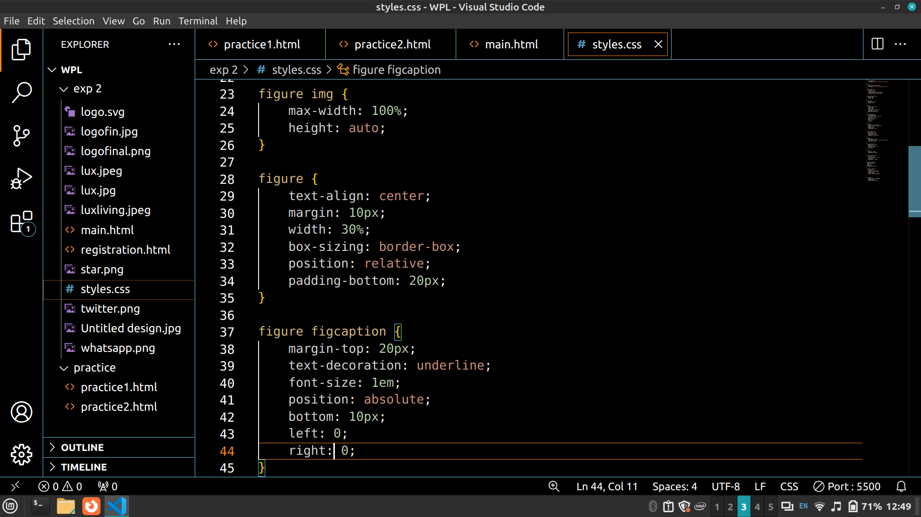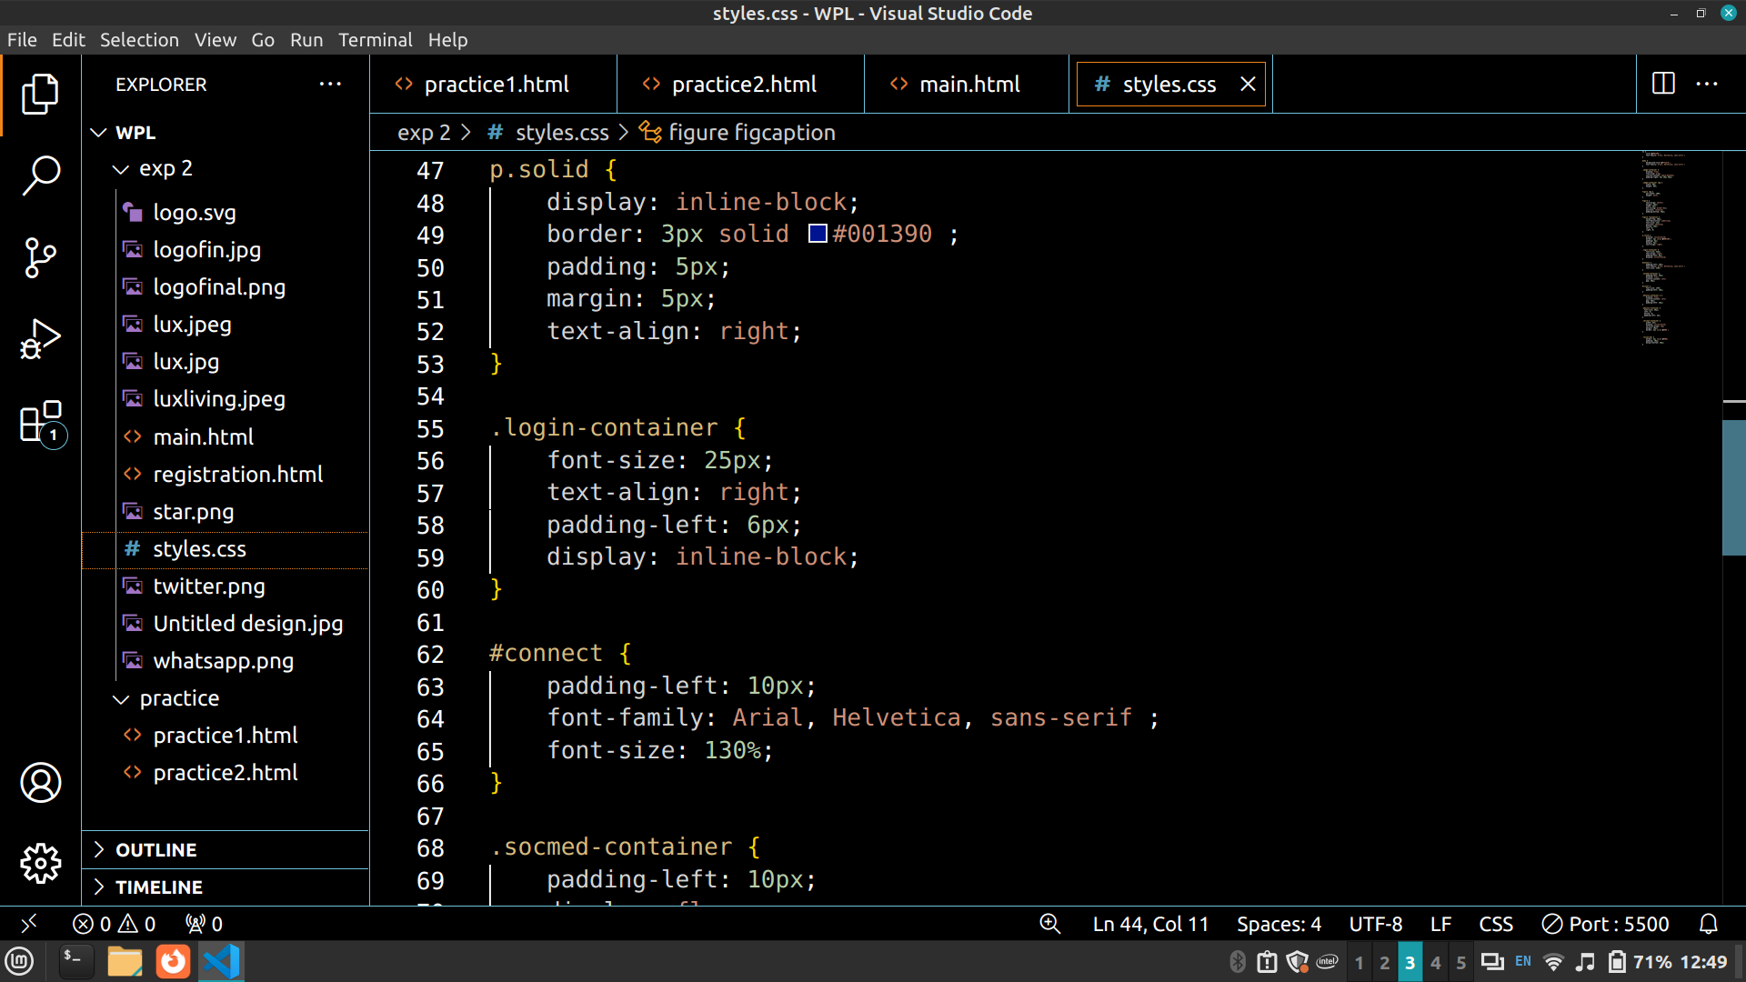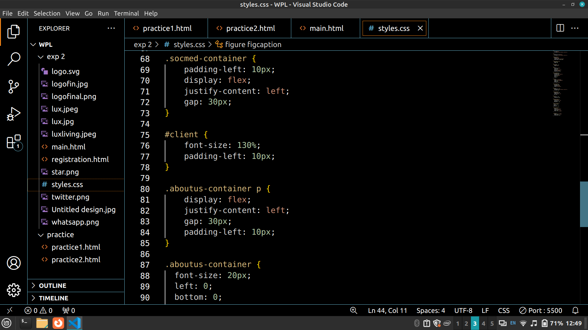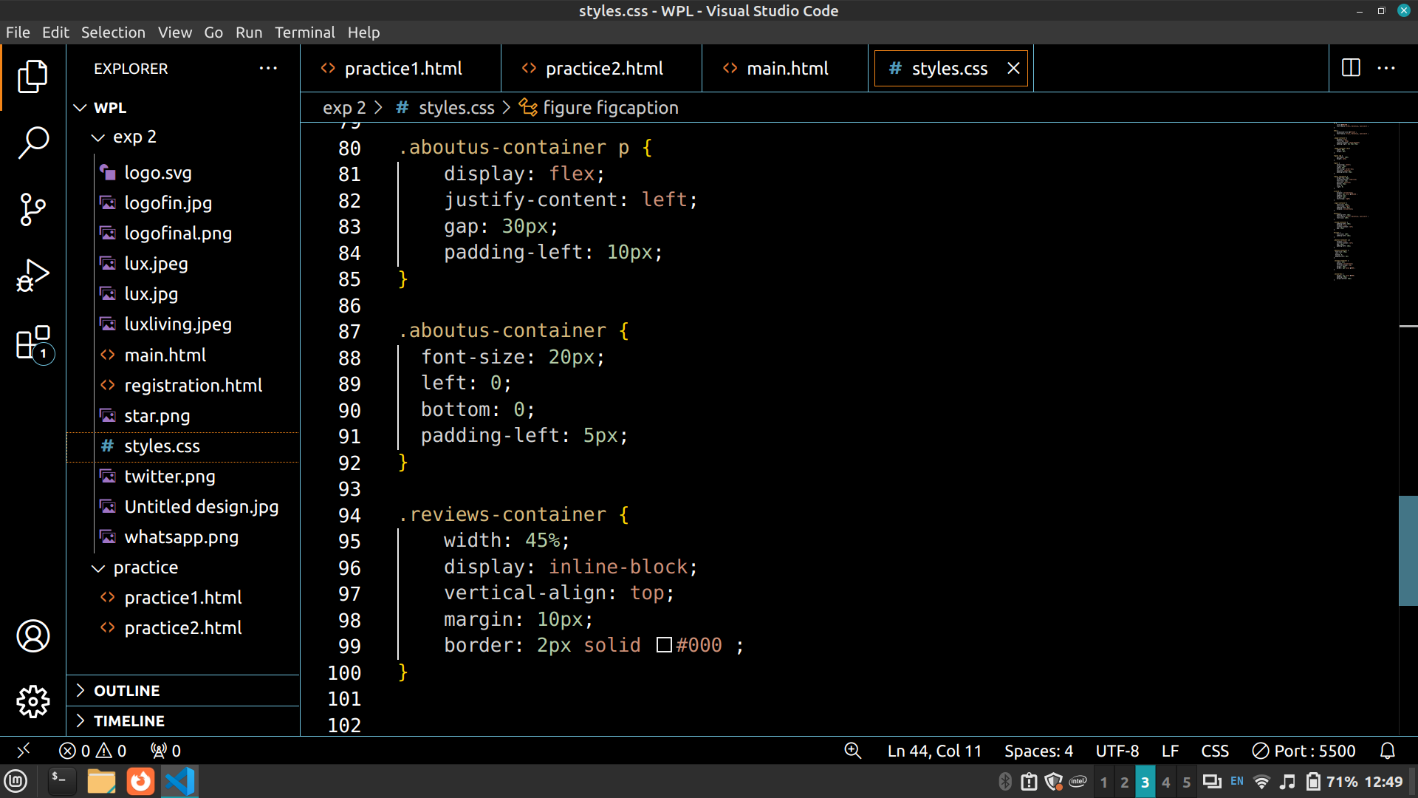

Code
main.html
<!doctype html>
<html lang="en-US">

<head style="font-family: Arial, Helvetica, sans-serif";>

<meta charset="utf-8" />

<img src="luxliving.jpeg" height="30%" width="30%" style="border-style: solid; border-color: #001390;">

<title>Luxe Living Realty</title>

<h2 style="padding-left: 10px; text-align: right; color: #001390;">
<em>Your Key to Exceptional Properties!</em></h2>

<hr style="color: #001390;">

<link rel="stylesheet" href="styles.css"/>

</head>

<body>

<div class="login-container">
<p class="solid">Login</p>
<p class="solid">Sign Up</p>
</div>

<p style="font-size: 130%; padding-left: 10px;"><b>Top Locations</b></p>

<div class="image-container">

<figure>
<img src="house6.jpg"
>
<figcaption>
Seychelles
</figcaption>
</figure>

<figure>
<img src="house1.jpg"
>
<figcaption>
The Hamptons
</figcaption>
</figure>

<figure>
<img src="house2.jpg"
>
<figcaption>
The Maldives
</figcaption>
</figure>

</div>

<div class="image-container">

<figure>
<img src="house3.jpg"
>
<figcaption>
Bali
</figcaption>
</figure>

<figure>
<img src="house4.jpg"
>
<figcaption>
Fiji
</figcaption>
</figure>

<figure>
<img src="house5.jpg"
>
<figcaption>
Rome
</figcaption>
</figure>

</div>

<hr>

<p id="client"><b>
Client Reviews</b></p>

<div class="reviews-container" style="color: #00083c;">
<p style="font-family: Verdana, Geneva, Tahoma, sans-serif; color: #001390;">
<b>Kareena Shah</b>
<img src="star.png" height="5%" width="3%">
<img src="star.png" height="5%" width="3%">
<img src="star.png" height="5%" width="3%">
<img src="star.png" height="5%" width="3%"></p>
Absolutely stunning! Luxe Living Realty made my dream of finding the perfect home a reality. Their website is not just user-friendly but also visually captivating. I found exactly what I was looking for in no time. Highly recommend!
</p>
</div>

<div class="reviews-container" style="color: #00083c;">
<p style="font-family: Verdana, Geneva, Tahoma, sans-serif; color: #001390;">
<b>Jitendra Singh</b>
<img src="star.png" height="5%" width="3%">
<img src="star.png" height="5%" width="3%">
<img src="star.png" height="5%" width="3%">
<img src="star.png" height="5%" width="3%">
<img src="star.png" height="5%" width="3%"></p>
Five-star experience! Luxe Living Realty's website sets the bar high for real estate platforms. The seamless navigation and extensive property listings made my house hunting journey effortless. Kudos to the team for their impeccable service!
</p>
</div>

<div class="reviews-container" style="color: #00083c;">
<p style="font-family: Verdana, Geneva, Tahoma, sans-serif; color: #001390;">
<b>Sheena Vohra</b>
<img src="star.png" height="5%" width="3%">
<img src="star.png" height="5%" width="3%">
<img src="star.png" height="5%" width="3%">
<img src="star.png" height="5%" width="3%"></p>
Exceptional service! Luxe Living Realty's website exceeded my expectations. From browsing luxurious properties to contacting agents, everything was smooth and efficient. A top-notch platform for anyone in search of premium real estate
</p>
</div>

<div class="reviews-container" style="color: #00083c;">
<p style="font-family: Verdana, Geneva, Tahoma, sans-serif; color: #001390;">
<b>Vamika Shukla</b>
<img src="star.png" height="5%" width="3%">
<img src="star.png" height="5%" width="3%">
<img src="star.png" height="5%" width="3%">
<img src="star.png" height="5%" width="3%">
<img src="star.png" height="5%" width="3%"></p>
Impressive! Luxe Living Realty's website is a game-changer in the real estate industry. The attention to detail and comprehensive property descriptions provided me with all the information I needed to make informed decisions. I couldn't be happier with my experience!
</p>
</div>

</div>
<p id="connect"><b>
Connect with us!
</p></b>

<div class="socmed-container">
<p><img src="instagram.png" width="40px" height="40x" ></p>
<p><img src="twitter.png" width="40px" height="40px"> </p>
<p><img src="whatsapp.png" width="40px" height="40px"> </p>
<p style="padding-right: 30px;"><img src="fb.png" width="40px" height="40px"></p>
</div>

<div class="aboutus-container">
<p>Our Mission</p>
<p>Our Team</p>
<p>Blog</p>
</div>

</body>

</html>

styles.css
h1 {
color:#001390 ;
font-family: Arial, Helvetica, sans-serif ;
}

body {
background-color:#ffeec0 ;
font-family: Arial, Helvetica, sans-serif ;
}

.image-container {
display: flex;
flex-wrap: wrap;
justify-content: space-between;
padding-right: 5px 10px 40px;
}

.image-container img {
width: 90%;
height: 90%;
}
figure img {
max-width: 100%;
height: auto;
}

figure {
text-align: center;
margin: 10px;
width: 30%;
box-sizing: border-box;
position: relative;
padding-bottom: 20px;
}

figure figcaption {
margin-top: 20px;
text-decoration: underline;
font-size: 1em;
position: absolute;
bottom: 10px;
left: 0;
right: 0;
}

p.solid {
display: inline-block;
border: 3px solid #001390 ;
padding: 5px;
margin: 5px;
text-align: right;
}

.login-container {
font-size: 25px;
text-align: right;
padding-left: 6px;
display: inline-block;
}

#connect {
padding-left: 10px;
font-family: Arial, Helvetica, sans-serif ;
font-size: 130%;
}

.socmed-container {
padding-left: 10px;
display: flex;
justify-content: left;
gap: 30px;
}

#client {
font-size: 130%;
padding-left: 10px;
}

.aboutus-container p {
display: flex;
justify-content: left;
gap: 30px;
padding-left: 10px;
}

.aboutus-container {
font-size: 20px;
left: 0;
bottom: 0;
padding-left: 5px;
}

.reviews-container {
width: 45%;
display: inline-block;
vertical-align: top;
margin: 10px;
border: 2px solid #000 ;
}

.review-box {
border: 2px solid #000;
padding: 10px;
margin-bottom: 20px;
}

Output Screenshots
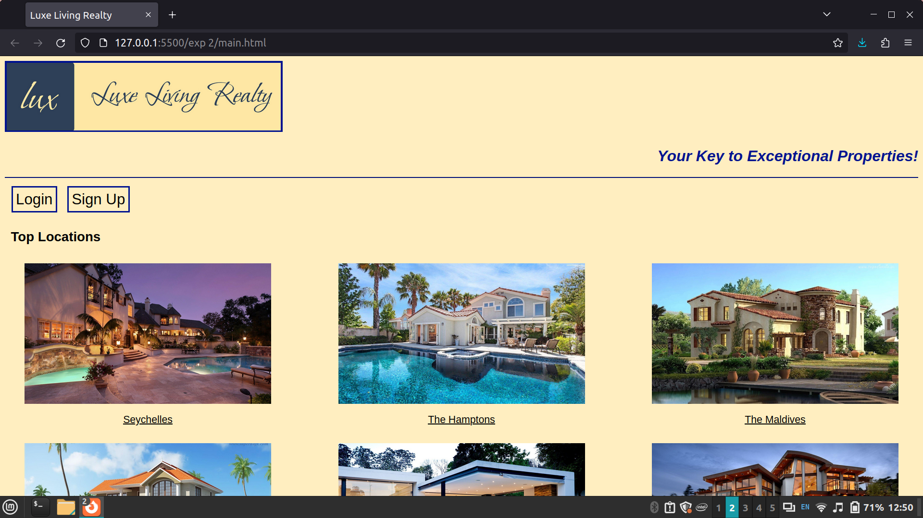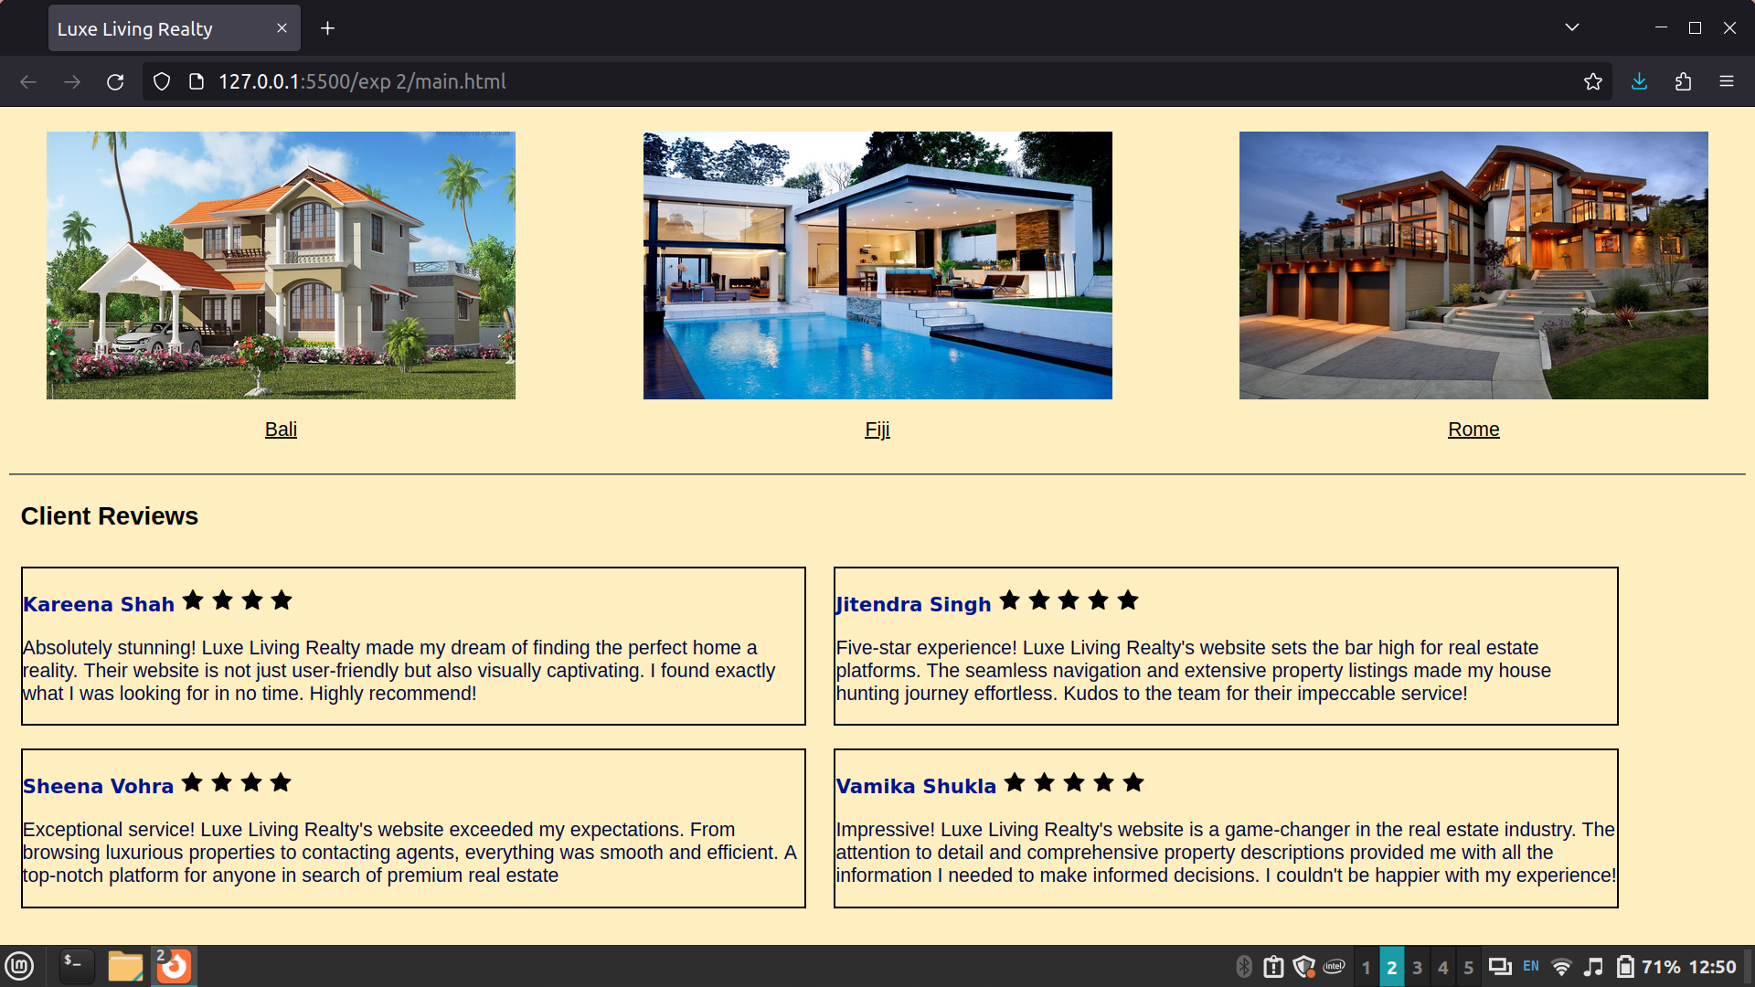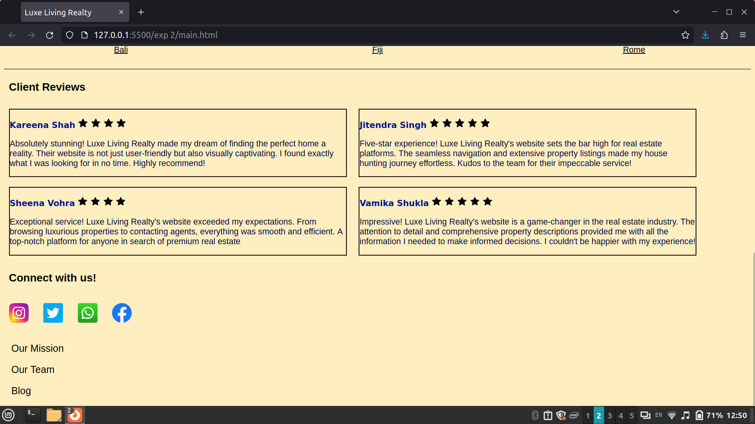

Post Lab Objective with Ans (Min 5):
- What is the Box model in CSS?
Everything in CSS has a box around it, and understanding these boxes is key to being able to create more complex layouts with CSS, or to align items with other items.
In CSS we have several types of boxes that generally fit into the categories of block boxes and inline boxes. The type refers to how the box behaves in terms of page flow and in relation to other boxes on the page. Boxes have an inner display type and an outer display type.

- What are the advantages of using CSS?
Some advantages of CSS are as follows:
- Consistency and Global Styling
- Easier to Maintain and Efficient Updates
- Time-Saving and Faster Loading Times
- Enhanced Design Options and Responsive Design
- SEO-Friendly
- Accessibility and Print-Friendly Pages
- Platform Independence and Device Compatibility
- CSS Minification and Page Load Efficiency
- Cascade, Inheritance, and Class/ID Usage
- CSS Sprites, Animations, and Effects

- What are the limitations of CSS?
Some limitations of CSS are as follows:
- Cross-Browser Issues and Browser Compatibility
- Learning Curve
- Security Concerns
- Complex Layouts and Limited Layout Control
- File Size and Performance Impact
- Over-Specificity and Overriding Styles
- Maintenance Challenges

- What are the different types of Selectors in CSS?
In CSS, selectors are patterns used to match, or select, the elements you want to style. Selectors are also used in JavaScript to enable selecting the DOM nodes to return as a NodeList.
Selectors, whether used in CSS or JavaScript, enable targeting HTML elements based on their type, attributes, current states, and even position in the DOM. Combinators allow you to be more precise when selecting elements by enabling selecting elements based on their relationship to other elements.

Reference

Combinators and separators
- + (Next-sibling combinator)
- > (Child combinator)
- || (Column combinator)
- Experimental

- ~ (Subsequent sibling combinator)
- " " (Descendant combinator)
- | (Namespace separator)

Selectors
- :active
- :any-link
- :autofill
- :blank
- :buffering
- :checked
- :current
- :current()
- :default
- :defined
- :dir()
- :disabled
- :empty
- :enabled
- :first-child
- :first-of-type
- :focus
- :focus-visible
- :focus-within
- :fullscreen
- :future
- :has()
- :hover
- :indeterminate
- :in-range
- :invalid
- :is()
- :lang()
- :last-child
- :last-of-type
- :link
- :local-link
- :matches() (obsolete legacy selector alias for :is())
- :modal
- :muted
- :not()
- :nth-child()
- :nth-of-type()
- :nth-last-child()
- :nth-last-of-type()
- :only-child
- :only-of-type
- :optional
- :out-of-range
- :past
- :paused
- :picture-in-picture
- :placeholder-shown
- :playing
- :read-only
- :read-write
- :required
- :root
- :scope
- :seeking
- :stalled
- :target
- :target-within
- :user-invalid
- :user-valid
- :valid
- :visited
- :volume-locked
- :where()
- :-webkit- pseudo-classes
- Attribute selectors
- Class selector
- ID selectors
- Type selectors
- Universal selectors

